The Securities and Futures Commission takes no responsibility for the contents of this announcement, makes no representation as to its accuracy or completeness and expressly disclaims any liability whatsoever for any loss howsoever arising from or in reliance upon the whole or any part of the contents of this announcement.

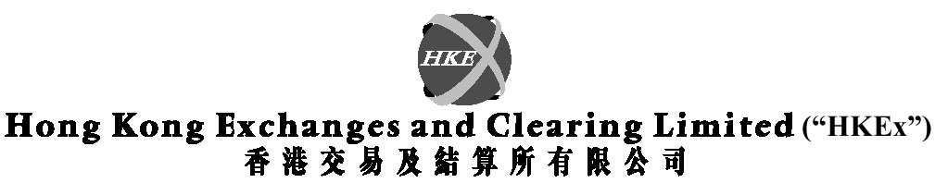
(Incorporated in Hong Kong with limited liability under the Companies Ordinance)

Announcement

Removal of the SEHK’s portion of Transaction Levy (0.005%) and Introduction of a Trading Fee by SEHK at the same rate of 0.005% per side of the consideration of a transaction

Pursuant to Section 52(1) of the Securities and Futures Commission Ordinance, the purchaser and the seller of a securities transaction recorded on or notified to The Stock Exchange of Hong Kong Limited (“SEHK”), shall each of them be liable to pay to the Securities and Futures Commission (“SFC”) a Transaction Levy at such rate as may be specified by order of the Chief Executive in Council. At present, the Transaction Levy is charged at the rate of 0.01% per side of the consideration of a transaction and the levy income collected is equally shared between the SFC and SEHK.

Since SEHK has become a wholly-owned subsidiary of HKEx which is a commercial entity, it is no longer justifiable for SEHK to rely on the statutory Transaction Levy as a source of income. Following discussions between HKEx and the SFC, it is agreed that the share of the levy income by SEHK would be removed, and the legislative changes to effect that would be gazetted on 6 April 2001. At the same time, SEHK has proposed to introduce a Trading Fee, which would be set at the same rate as its current share of levy income, i.e. 0.005% per side of the consideration of a transaction. Save and except that this particular source of revenue is subject to market turnover fluctuations, as is the case with the Transaction Levy currently, the new arrangement would be neutral on SEHK’s revenue. The said Trading Fee is subject to the SFC’s approval, which is expected to be forthcoming, and would take effect upon the removal of the SEHK’s portion of Transaction Levy. The Fee level would be subject to review by the SFC and SEHK after a year of its coming into effect.

By order of the Board
Hong Kong Exchanges and Clearing Limited
Joseph Mau
Company Secretary

Hong Kong, 4 April 2001

Please also refer to the published version of this announcement in the SCMP dated 5/4/2001.

